Best SkyTorrents Proxy — What Users Search For & Safer Alternatives
When you search for the best SkyTorrents proxy, you’re likely looking for a way to access content that was once available on SkyTorrents, a popular torrent indexing platform. SkyTorrents became known for its clean interface, minimal ads, and wide selection of torrent files. But, like many torrent sites, it was eventually taken down due to copyright and legal challenges.
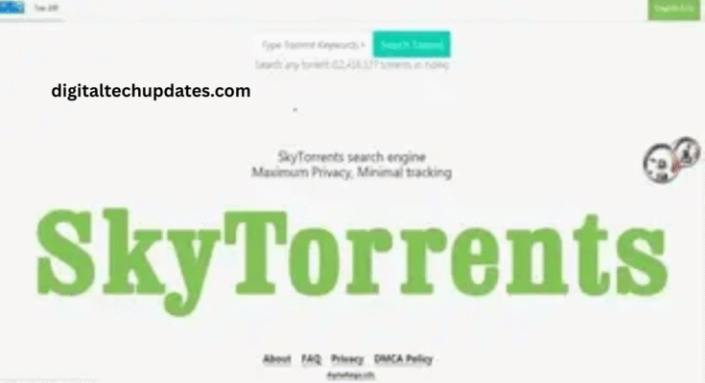
Today, dozens of “proxy” or “mirror” sites claim to replace SkyTorrents, but most come with serious risks — from malware to phishing scams. This article explains why people search for SkyTorrents proxies, the dangers of relying on them, and the safe alternatives you should consider instead.
Why do people search for “best SkyTorrents proxy”?
To bypass restrictions: SkyTorrents domains are blocked in many regions.
To access a familiar interface: Some users liked its clean, clutter-free design.
For free downloads: Movies, music, software, and ebooks without paying.
For nostalgia: Returning users who heard about SkyTorrents’ reputation.
While those reasons explain the interest, proxy hunting is neither safe nor sustainable.
The hidden risks of SkyTorrents proxies
Legal consequences – Downloading or distributing copyrighted files can violate intellectual property laws.
Malware & scams – Many proxy clones contain fake buttons, popups, and malicious scripts.
Privacy exposure – Torrenting openly shares your IP address, making you traceable.
Unreliable content – Low-quality or mislabeled files are common on fake mirrors.
Ethical impact – Piracy harms the creators and industries producing the content.
Safer, Legal Alternatives to SkyTorrents
If you’re searching for the best SkyTorrents proxy, it’s worth asking: do you really need one? These legal alternatives often provide the same convenience:
🎬 Movies & TV
Netflix, Amazon Prime Video, Disney+ Hotstar, HBO Max, Apple TV+
Ad-supported free options: Tubi, Pluto TV, Crackle, MX Player
🎮 Games & Software
Steam, Epic Games Store, GOG for legal downloads
Freeware & Open Source: SourceForge, GitHub projects
📚 Books & Educational Content
Project Gutenberg, Internet Archive, Open Library
Kanopy, Hoopla (with library access)
🎶 Music
Spotify, YouTube Music, SoundCloud — free or subscription tiers
These choices provide safe, high-quality experiences without malware or legal headaches.
Final Thoughts
Looking for the best SkyTorrents proxy may seem like a shortcut, but it comes with hidden costs. Proxy and mirror sites are risky, often illegal, and rarely deliver what they promise. Instead, opt for licensed streaming services, ad-supported platforms, open-source downloads, or public domain archives.

