💰 Plastic Surgery Price in Hyderabad – A Complete Cost Guide for Patients
If you are considering cosmetic or reconstructive plastic surgery, one of the first questions on your mind is likely: “What is the plastic surgery price in Hyderabad?” Understanding the cost helps you plan smartly, compare options, and make informed decisions about your aesthetic journey.
Hyderabad is one of India’s leading cities for advanced plastic surgery treatments. From facial rejuvenation to body contouring, the city’s skilled surgeons and modern facilities offer high-quality care at competitive costs — often lower than international standards.
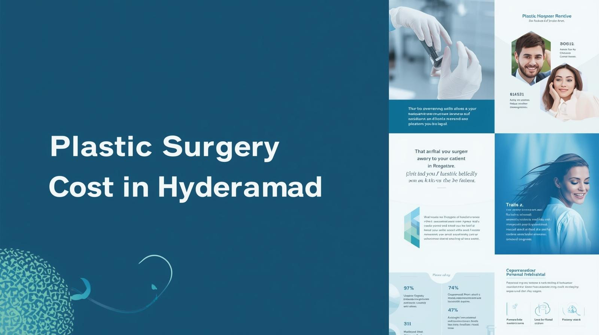
In this comprehensive guide, we break down typical plastic surgery price ranges in Hyderabad, explain the factors that influence cost, and help you understand how to choose the right surgeon without compromise.
Key Factors That Influence Plastic Surgery Cost
Several elements play a role in determining the plastic surgery price in Hyderabad:
🧑‍⚕️ 1. Surgeon’s Experience & Reputation
Highly experienced surgeons with specialized expertise often charge more — but this investment is worth it for safety, natural results, and fewer complications.
🏥 2. Hospital or Surgical Facility Fees
Costs include operation theatre charges, nursing support, recovery rooms, and facility overheads, which vary by hospital.
💉 3. Type of Anesthesia Used
Some surgeries require general anesthesia, while others may use local anesthesia with sedation — anesthesia costs impact the total price.
📋 4. Complexity of the Procedure
More extensive or long surgeries (like combined surgeries or reconstructive work) can increase costs due to time, materials, and planning involved.
📅 5. Pre- and Post-Operative Care
Consultations, diagnostic tests, medications, compression garments, and follow-up visits all contribute to the final cost.
🌟 Why Price Isn’t the Only Thing to Consider
While cost is important, choosing the best surgeon and safe surgical environment should be your top priority. Low prices may seem appealing, but they can reflect in:
❌ Less experienced surgical skills
❌ Outdated equipment or unsafe facilities
❌ Higher risk of complications
❌ Poor aesthetic results or asymmetry
Opting for a qualified, board-certified plastic surgeon with a proven track record — like those at Dr. Divya Plastic Surgeon Clinic — ensures quality results that justify the investment.
🧠 How to Plan Your Cosmetic Surgery Budget
When planning your plastic surgery, keep these tips in mind:
💡 1. Consult a Specialist
Get a detailed assessment and customized cost estimate from a qualified surgeon.
💡 2. Understand What’s Included
Ensure your quote covers surgeon fees, facility charges, anesthesia, and follow-ups.
💡 3. Ask About Financing Options
Some clinics offer easy payment plans or EMIs to make surgery affordable.
💡 4. Focus on Value, Not Just Price
Compare surgeons based on expertise, results, and patient reviews — not just cost.
💬 Real Patient Example
Many patients in Hyderabad report that investing in a qualified plastic surgeon led to safer outcomes, faster healing, and results that matched their expectations. Patients who choose experienced specialists often spend slightly more — but save time, discomfort, and disappointment in the long run.
🧑‍⚕️ Why Choose Plastic Surgery in Hyderabad?
Hyderabad is a top destination for plastic and cosmetic surgery due to:
✔ Highly skilled, board-certified surgeons
✔ Competitive pricing compared to metropolitan cities
✔ Modern hospitals with advanced technology
✔ Personalized care and follow-up support
✔ A wide range of aesthetic and reconstructive procedures
🔍 Final Thoughts
Understanding the plastic surgery price in Hyderabad helps you plan responsibly and choose the best care for your needs. Whether you are considering rhinoplasty, tummy tuck, liposuction, or reconstructive surgery, informed decisions lead to better outcomes and greater satisfaction.
contact us;drdivyaplasticsurgeon@gmail.com

