
The Art of Timeless Luxury: Exploring the Beauty, Craftsmanship, and Heritage of Fine Cashmere Shawls

Introduction
Cashmere shawls are a true expression of timeless luxury and refined craftsmanship. Known for their unmatched softness, lightweight warmth, and elegant drape, these exquisite pieces have been treasured for centuries. Each shawl embodies a perfect harmony of tradition and style, making it not just an accessory but an heirloom of comfort and grace. From the chill of winter evenings to the sophistication of formal gatherings, a cashmere shawl adds effortless elegance to every occasion.
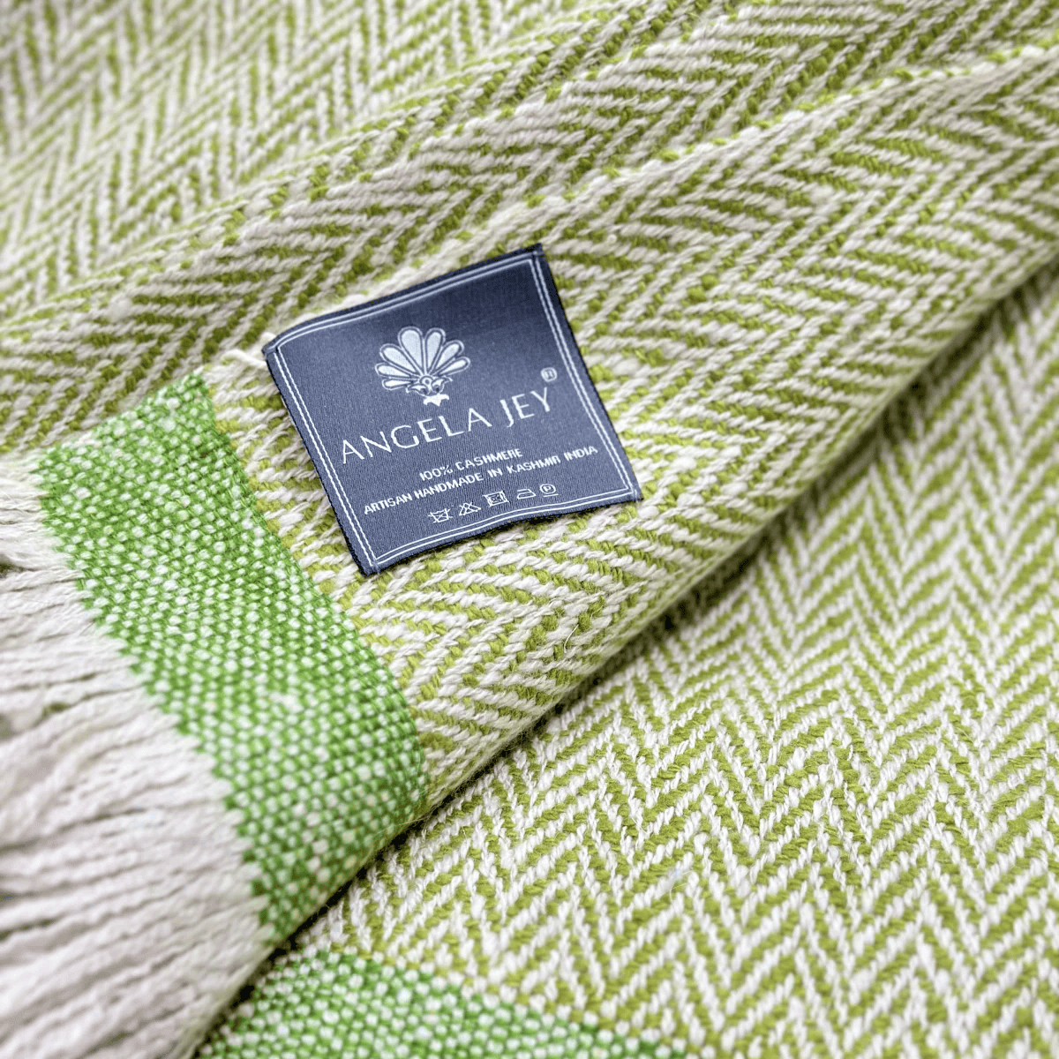
Origin and Material Excellence
True cashmere comes from the fine undercoat of Himalayan mountain goats, raised in the cold, high-altitude regions of the Himalayas. The fibre’s rare quality and limited availability make it one of the most sought-after natural materials in the world. Each strand of cashmere is incredibly soft, warm, and resilient. When handwoven into a shawl, it results in a fabric that feels luxurious against the skin yet is light enough to float in the breeze.
The process of creating these shawls begins with collecting raw pashmina wool, hand spinning it into fine yarns, and weaving it on traditional looms. Skilled artisans dedicate hours, sometimes days, to ensure the weave is even, smooth, and flawless. This blend of artistry and patience results in an accessory that reflects both cultural heritage and contemporary fashion.

Design and Craftsmanship
Cashmere shawls are admired for their intricate craftsmanship and timeless appeal. They come in an array of designs — from solid colours and minimalistic weaves to detailed embroidery and jacquard patterns. Artisans often incorporate delicate motifs inspired by nature, geometry, and traditional Kashmiri designs.
Every shawl represents a combination of heritage techniques and modern sensibilities. Whether you prefer a classic neutral tone for everyday elegance or a richly embroidered piece for festive occasions, cashmere shawls offer versatile options that complement both casual and formal outfits.

Luxury with Purpose
Owning a cashmere shawl is more than a fashion statement — it’s an appreciation of sustainability and ethical craftsmanship. Many contemporary producers emphasize responsible sourcing, fair wages, and preservation of traditional handloom skills. By choosing authentic, handcrafted cashmere, you support artisanal communities and help sustain centuries-old weaving traditions that would otherwise fade in the era of mass production.

Benefits of Cashmere Shawls
- Unparalleled Softness: Feels gentle and soothing against the skin.
- Lightweight Warmth: Provides excellent insulation without heaviness.
- Durability: When cared for properly, cashmere lasts for years without losing its quality.
- Versatility: Perfect for layering with both western and ethnic attire.
- Sustainable Luxury: Ethically produced and naturally biodegradable.

Styling and Use
Cashmere shawls can be worn in countless ways — draped over the shoulders for a graceful look, wrapped snugly around the neck during cold weather, or paired with formal wear to elevate an evening outfit. Their natural sheen and rich texture make them a standout piece in any wardrobe.
For gifting, cashmere shawls hold deep meaning. They represent warmth, love, and timeless beauty — making them ideal presents for weddings, anniversaries, and festive occasions.

Care and Maintenance
To preserve the softness and shape of a cashmere shawl:
- Gently hand-wash in cold water with a mild detergent or opt for professional dry-cleaning.
- Avoid twisting or wringing; instead, reshape and lay flat to dry away from direct sunlight.
- Store folded in a breathable cotton bag to prevent stretching or moth damage.
- Handle delicately to maintain its original texture and lustre for years.

Conclusion
A fine cashmere shawl is a celebration of craftsmanship, heritage, and understated luxury. It bridges generations, symbolizing both comfort and sophistication. Each piece tells a story — of artisans’ dedication, nature’s rarest fibres, and timeless beauty that never fades. Whether you wear it for warmth, style, or sentiment, a cashmere shawl remains a lasting emblem of grace and elegance — a true masterpiece of textile artistry.

