

A First-Time Buyer's Guide to Cape Coral Houses for Sale
First-time buyers usually enter a new city with many questions but with few answers. But Cape Coral is a city where preparation pays off. Its canal system, flood zones, utility system, and varied neighborhoods affect the purchase process in such a way that no other city in Florida can match. The earlier you become acquainted with these features, the quicker you will be able to buy your new house.
This guide contains all the information that a first-time buyer should know.
1. Know Why Cape Coral Is Different
Cape Coral has more than 400 miles of navigable canals. It is the largest network in the world. This means that Cape Coral offers the most unique waterfront experience possible, although it does make things complicated for buyers to figure out.
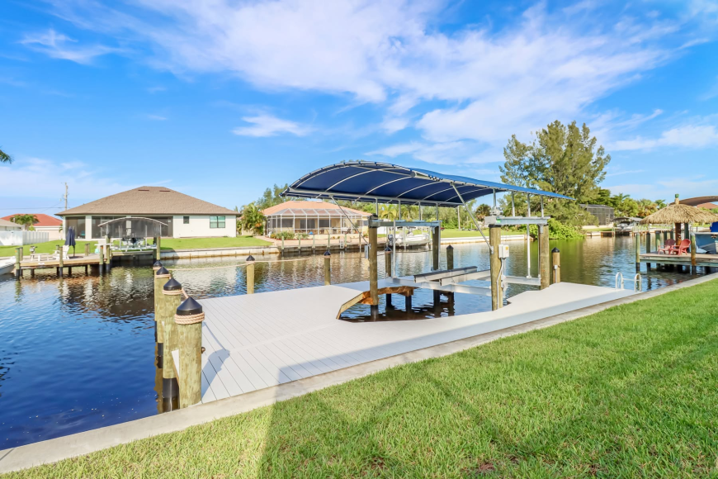

Cape Coral also has an ongoing expansion project on its main water and sewage systems. In some cases, the home will be serviced by municipal utilities, whereas in others, a well and septic tank will be used.
Knowing about these two factors can give you the upper hand from day one as a first-time buyer of Cape Coral houses for sale.
2. Know Your Canal Types Before You Buy a Home
Not all waterfront properties in Cape Coral have equal accessibility. Cape Coral has canals that can be classified as either freshwater or saltwater.
As the name suggests, freshwater canals have no connection with the Gulf of Mexico. If one wants to purchase a property with a water view, then this is the type of canal to look for. However, saltwater canals, also referred to as gulf access canals, have connections with the Caloosahatchee River and ultimately the open water. This type attracts boaters and has high resale values.
Sailboat access properties occupy the most superior position among saltwater properties, and they are on canals with no fixed bridges that hinder access to open water.
When you buy a home in Cape Coral, always ascertain its canal type, FEMA flood zone classification, and seawall status first.
3. Always Check Utility Assessments Before Making an Offer
As utility improvements continue to take place in Cape Coral, there are properties whose utility assessments for water, sewer, and stormwater systems have yet to be paid. In case you buy a lot where such assessments exist, the responsibility of paying falls on you.
Always check the utility assessment of the property before making an offer. Check whether it is served by city utilities or if it runs on a well and septic. Those buyers who neglect this aspect usually find themselves in trouble due to unforeseen expenses.All the Cape Coral houses for sale, however, which do not have utility assessment issues, make the easiest choice.
4. Focus on Hurricane Protection
Building standards in Cape Coral have improved dramatically. Homes constructed in Cape Coral nowadays adhere to the current Florida Building Codes, with features such as impact glass windows, enhanced roofing, and appropriate elevation.However, older homes need closer scrutiny. When examining resale properties, consider checking out their roof for signs of damage or aging. Also, ask whether they have hurricane protection glass or shutters. This is because these factors directly impact the price of your homeowners' insurance policy. Homebuyers who prefer to buy a home in Cape Coral through new construction do not have to worry about these issues at all.
Discover Neighborhoods that Suit Your Needs
There are different kinds of neighborhoods within Cape Coral that are distinguished by varying costs, canal availability, and lifestyles. Here is a brief guide to what each kind entails for those who plan to buy a home in Cape Coral for the first time:
- Northwest Cape Coral – Characterized by new constructions, bigger plots, and canals with both freshwater and indirect Gulf access. A suitable option for those looking to buy new and accessible homes.
- Southwest Cape Coral – This is the prime area characterized by direct Gulf access. Real estate in this area costs more but appreciates significantly in the long run.
- Northeast Cape Coral – Characterized by mostly freshwater canals with the most affordable pricing. This would be ideal for those buying properties for the first time.
- Southeast Cape Coral – Includes old Cape Coral houses for sale and new constructions. Accessible to the downtown area of Cape Coral as well as restaurants and other amenities.

What Makes Sposen Signature Homes the Best Choice for First-Time Buyers
Sposen Signature Homes constructs brand-new homes in Cape Coral and lists Cape Coral houses for sale, with a total of 65 years of experience in constructing houses. They have a variety of floor plan options, from smaller Lifestyle Series plans to bigger Elite Series plans and even specialize in building multigenerational residences and duplexes.
Site preparation costs for the permit, impact fees, and prep work are included in every property to provide buyers with the certainty of knowing their total price.
BuildersTrend consumer portal provides each customer access to their construction schedule and milestone information from anywhere. This eliminates the mystery surrounding the building process that first-time buyers usually experience.
If you are about to buy your first home in Cape Coral, Sposen Signature Homes will not only provide the product of your choice but will also assist you throughout the process confidently. Look through all the available Cape Coral houses for sale at sposenhomes.com.
For More Information
Address- 2311 Santa Barbara Blvd, Suite 112, 33991 Cape Coral, Florida, USA
Toll-Free -239-244-8886
Email ID- hello@sposenhomes.com
Website: https://sposenhomes.com

