Best Dimple Creation Surgeon in Hyderabad – Get the Perfect Smile
Looking for the Best Dimple Creation Surgeon in Hyderabad to enhance your smile naturally? Hyderabad is home to expert plastic surgeons who specialize in cosmetic facial procedures, including dimple creation surgery. If you’re considering this aesthetic enhancement, choosing the right surgeon is critical for safe, beautiful results.
At Dr. Divya’s Plastic Surgery, patients seeking natural-looking dimples get personalized care and trustworthy expertise. Whether you want subtle facial enhancement or a more prominent smile feature, a skilled surgeon ensures balanced, symmetrical results that complement your face.
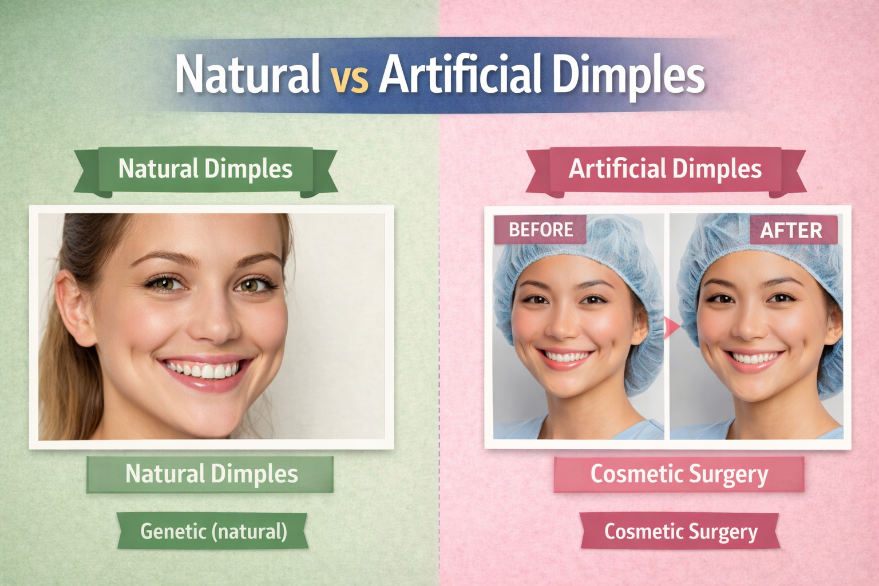
👩‍⚕️ Why Choose the Best Dimple Creation Surgeon in Hyderabad
✔ Specialized Expertise in Aesthetic Surgery – The best surgeons have extensive training in facial cosmetic procedures, ensuring safe and effective dimple creation.
✔ Personalized Consultations – Individualized treatment planning tailored to your face shape and desired outcome.
✔ Natural-Looking Results – Precision techniques that create natural dimples with minimal scarring.
✔ Comfortable Clinic Experience – Supportive care from consultation to post-procedure recovery.
If you want to learn about the difference between natural and artificial dimples before booking your surgery, there’s a helpful article that breaks it down.
💡 What Is Dimple Creation Surgery?
Dimple creation surgery (also called dimpleplasty) is a cosmetic procedure that forms facial dimples on the cheeks. It’s a simple outpatient procedure that can give you the charming, natural dimples you’ve always wanted.
The right surgeon in Hyderabad will understand facial anatomy and use precise techniques to ensure:
🔹 Symmetrical dimples
🔹 Minimal discomfort
🔹 Fast recovery
🔹 Results that look natural and enhance your smile
😊 Benefits of Choosing an Expert Surgeon
✨ Safety First: A certified and experienced surgeon ensures proper assessment and safe surgical execution.
✨ Customized Results: Dimples are placed and shaped based on your facial features — no “one-size-fits-all.”
✨ Confidence Boost: Natural-looking dimples can enhance your smile and overall appearance.
Before you decide, it’s important to read up on how natural dimples differ from artificial ones and what to expect from the procedure. The blog linked above explains it in clear detail for anyone considering dimpleplasty.
🌟 Get Started with the Best Dimple Creation Surgeon in Hyderabad
If you’re ready to enhance your smile with beautiful, natural dimples, start by learning more about the procedure and choosing a trusted expert in Hyderabad.
contact us;divyaplasticsurgeon@gmail.com

