Social media engagement for business refers to how actively your audience interacts with your brand on social platforms such as Facebook, Instagram, LinkedIn, X (Twitter), and YouTube. Engagement includes likes, comments, shares, saves, clicks, and direct messages. High engagement shows that your content resonates with your audience and helps build long-term brand relationships.
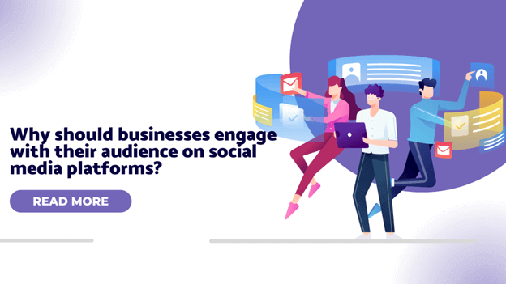
Why Social Media Engagement Is Important for Business Growth
Strong social media engagement helps businesses increase brand visibility, build trust, and improve customer loyalty. When users engage with your posts, social media algorithms promote your content to a wider audience, leading to higher organic reach and better brand recognition.
Key Benefits of Social Media Engagement for Businesses
- Improves brand awareness and online presence
- Builds credibility and customer trust
- Drives website traffic and lead generation
- Encourages customer feedback and interaction
- Boosts conversion rates and sales
Types of Social Media Engagement That Matter
Different engagement actions indicate different levels of user interest:
- Likes & Reactions: Show quick approval of content
- Comments: Indicate deeper interest and conversation
- Shares & Reposts: Expand brand reach organically
- Saves: Reflect valuable or informative content
- Clicks & DMs: Show strong intent and potential leads
Effective Strategies to Increase Social Media Engagement
To improve social media engagement for business, focus on:
- Posting high-quality and relevant content consistently
- Using eye-catching visuals, reels, and short videos
- Writing engaging captions with clear calls-to-action
- Responding quickly to comments and messages
- Running polls, contests, and interactive stories
Role of Social Media Engagement in Digital Marketing
Social media engagement plays a vital role in digital marketing by helping businesses understand audience behavior and preferences. Higher engagement improves ad performance, strengthens brand authority, and supports overall SEO and content marketing efforts.
Measuring Social Media Engagement for Business Success
Businesses can track engagement using metrics such as engagement rate, reach, impressions, click-through rate (CTR), and follower growth. Analyzing these metrics helps optimize content strategies and improve ROI.
Conclusion
Social media engagement for business is not just about posting content—it’s about building meaningful interactions with your audience. By focusing on engagement-driven strategies, businesses can strengthen their online presence, connect with customers, and achieve sustainable growth.
Contact Us: thallalokesh@gmail.com
Read More: https://www.thallalokesh.com/

