Bottle top filters are specialized filtration devices designed to fit onto the top of laboratory bottles. They allow scientists, researchers, and lab technicians to filter liquids quickly and efficiently, ensuring that unwanted particulates, bacteria, or other impurities are removed before storage or use in experiments.These filters are especially vital in applications requiring sterile filtration, cell culture media preparation, and solvent filtration.
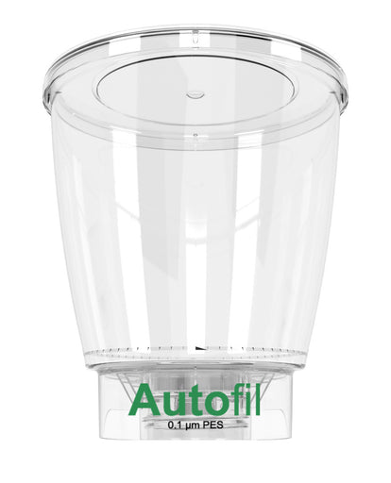
Why Choose Foxx Life Sciences Bottle Top Filters?
Foxx Life Sciences is a trusted name in laboratory solutions, known for their high-quality, durable, and reliable lab equipment. Their range of bottle top filters stands out for:
High Flow Rates: Designed for quick filtration without compromising sterility.
Durable Construction: Made with premium materials like PES, Nylon, or PVDF membranes.
Wide Compatibility: Available in various membrane pore sizes (0.1µm, 0.2µm, 0.45µm) to suit diverse applications.
Chemical Resistance: Suitable for a wide range of solvents and solutions.
Ergonomic Design: Easy-to-use and compatible with most standard laboratory bottles.
Key Features of Foxx Life Sciences Bottle Top Filters
Sterile and non-sterile options available
Lightweight, break-resistant design
Leak-proof vacuum filtration setup
Wide range of membrane materials and pore sizes
Color-coded caps for easy identification
Packaged for convenience and safety
Applications
Cell culture media filtration
Solvent purification
Aqueous and organic solution filtration
Protein and enzyme filtration
Microbiological analysis
Benefits of Using Foxx Life Sciences Bottle Top Filters
Maintains sterility and purity in sensitive applications
Reduces filtration time with high flow rates
Compatible with various solvents and chemicals
Minimizes cross-contamination risks
Reliable, lab-tested quality trusted globally

Frequently Asked Questions (FAQs)
Q1: What pore sizes are available in Foxx Life Sciences bottle top filters?
A: They are available in 0.1µm, 0.2µm, and 0.45µm pore sizes, suitable for different lab applications.
Q2: Can these filters handle solvent filtration?
A: Yes — Foxx Life Sciences bottle top filters are compatible with a range of aqueous and organic solvents.
Q3: Are the filters pre-sterilized?
A: Foxx Life Sciences offers both sterile and non-sterile options to suit specific laboratory needs.
Q4: Where can I purchase Foxx Life Sciences bottle top filters?
A: You can purchase them through authorized distributors or directly from the official Foxx Life Sciences website.
Final Thoughts
When precision, safety, and reliability matter in your laboratory processes, Foxx Life Sciences bottle top filters are the perfect choice. Their superior build, ease of use, and consistent filtration performance make them a trusted option for professionals in research, clinical, and industrial labs worldwide.
Contat Us: sales@foxxlifesciences.com
https://www.facebook.com/foxxlifesciences
https://twitter.com/foxxlifescience
https://www.linkedin.com/company/foxxlifesciences
https://www.youtube.com/user/foxxlifesciences

