Actvid — What It Is, Risks of Using It & Safer Alternatives
Quick answer: Actvid is (or was) a free online streaming platform known for hosting movies and TV shows without licenses. Many users search for Actvid movies or Actvid streaming to watch content for free. While the site gained attention for its wide library, there are serious legal, security, and ethical risks linked to such platforms. Here’s what you should know before using Actvid and what safer alternatives exist.
What is Actvid?
Actvid became popular as a website that allowed users to stream the latest movies and TV shows at no cost. Unlike licensed platforms, Actvid didn’t always hold the proper distribution rights, making it part of the “free streaming site” ecosystem that attracts both viewers and takedowns.
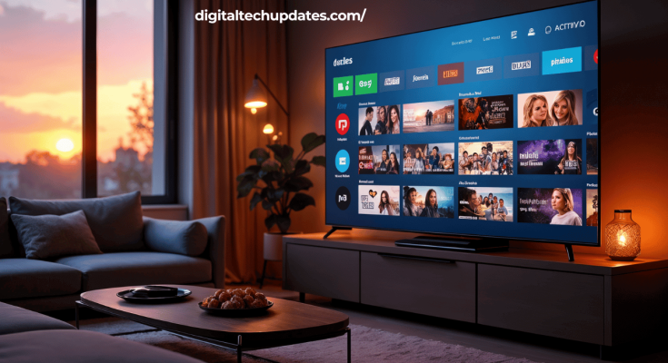
Like many similar platforms, Actvid often faces domain changes, shutdowns, and the rise of mirrors or proxies trying to imitate the original site.
Why people look for Actvid
- Access to new releases for free
- No sign-up or subscription needed
- A wide selection of movies and series across genres
The risks of using Actvid
1. Legal Issues
Streaming copyrighted content from unlicensed sources can be illegal in many countries. Even if enforcement varies, users may face ISP warnings, penalties, or other legal action.
2. Security Threats
Free streaming sites often rely on intrusive ads, fake “Play” or “Download” buttons, and suspicious redirects. These can lead to:
- Malware or adware infections
- Phishing pages
- Spyware tracking your activity
3. Privacy Risks
Sites like Actvid may log user data or push shady extensions that harvest personal information.
4. Unreliable Quality
Broken links, buffering, poor video quality, and frequent downtime are common with Actvid and its mirrors.
5. Ethical Concerns
Piracy reduces income for creators, actors, and filmmakers. It affects funding for future projects, especially for smaller studios.
Safer & Legal Alternatives to Actvid
Instead of risky platforms, consider these legal and secure services:
- Subscription Platforms: Netflix, Amazon Prime Video, Disney+ Hotstar, Hulu, HBO Max, Apple TV+
- Ad-Supported Free Platforms: Tubi, Pluto TV, Crackle, MX Player (region-based)
- Rent or Buy Movies: Google TV, iTunes, YouTube Movies
- Public-Domain & Free Legal Content: Internet Archive, Kanopy, Hoopla
These provide higher-quality streams, better safety, and fair support to creators.
Safety Tips if You Land on Sites Like Actvid
- Don’t click suspicious “Download” buttons
- Avoid installing unknown extensions or apps
- Use an updated antivirus and ad-blocker
- Prefer licensed streaming services for safe access
FAQs
Q: Is Actvid legal?
A: In most regions, no. Streaming unlicensed content is considered illegal and can carry risks.
Q: Does Actvid give viruses?
A: While Actvid itself may not, many mirrors and pop-ups linked to it can deliver malware or adware.
Q: What’s the best alternative to Actvid?
A: Legal streaming services like Netflix, Amazon Prime, Disney+ Hotstar, and ad-supported platforms like Tubi or Pluto TV are safe options.
Final Thoughts
Actvid may look like a quick solution for free streaming, but the downsides — legal exposure, malware risks, privacy concerns, and unreliable quality — outweigh the convenience. For a safe and enjoyable experience, choose official streaming services that protect you and support the content creators.

